Capstone Project Phase A

**Personal Budget Tracker**

25-1-D-26

Supervisor:

Dr. Zeev Frenkel

Noor Khateeb [Nour.El.Din.Khateb@e.braude.ac.il](mailto:Nour.El.Din.Khateb@e.braude.ac.il)

Shady Hijazy [Shady.hijazy@e.braude.ac.il](mailto:Shady.hijazy@e.braude.ac.il)

GitHub repository: <https://github.com/khatebnor29/Personal_Budget_Tracker>

Table of Contents

**Abstract** 4

1. Introduction 4

2. Background and Related Work 7

2.0 Budget Mismanagement 7

2.1 Existing tools Addressing the Problem 7

2.1.0 Personal Finance Applications 7

2.1.1 Banking Apps with Budgeting Features 9

2.1.2 Digital spreadsheets 12

2.1.3 Open-Source Financial Tools 14

2.1.4 Subscription Management Tools 17

2.2 Methods Addressing the problem 18

2.2.0 Budgeting Frameworks 18

2.2.1 Data Visualization 19

2.3 Existing Applications 19

Mint (Forbes, 2024): 20

YNAB(You Need A Budget) (NerdWallet, 2024): 20

EveryDollar (Forbes, 2024) : 21

Goodbudget (Kid's Money, 2024): 22

PocketGuard (Forbes, 2024): 22

2.4 Why Personal Budget Tracker (PBT) 23

3. Expected Achievements 24

3.1. Project Goals and Deliverables 24

3.2. Detailed Description of Achievements 25

3.2.1. Functional Features 25

3.2.2. Technical Components 26

3.3. Success Criteria 26

3.3.1. Functional Success 26

3.3.2. User Experience 26

3.3.3. Technical Performance 27

3.3.4. Overall Impact 27

4. The Process 27

4.1 *Research & Analysis -* *User issues* 27

4.2 Defining the product goals 27

4.3 what’s next ? 28

4.4 Motivation for the Approach and Workflow Stages 28

4.4.1 User-Centered Focus 28

4.4.2 Incremental Development 28

4.4.3 Innovation and Security 28

4.4.4 Commitment to Excellence 29

4.5 Constraints & Challenges 29

4.5.1 Technical Constraints 29

4.5.1.1 Data Security and Privacy 29

4.5.1.2 Integration with Financial Institutions 29

4.5.1.3 Scalability and Performance 29

4.5.2 User-Centric Challenges 30

4.5.3 Development Constraints 30

4.5.3.1 Time Constraints 30

4.5.3.2 Team Expertise 30

4.5.4 Market and Competitive Challenges 30

5. Algorithms 31

5.1 Input Data Format 31

5.1.1 Financial Transactions 31

5.1.2 User Budgets 31

5.1.3 Historical Data 31

5.2 Output of the Program 32

5.2.1 Insights and Recommendations 32

5.2.2 Visualizations 32

5.2.3 Exportable Reports 32

5.3 Algorithm Descriptions 32

5.3.1 K-means Clustering for Spending Behavior Analysis 32

5.3.2 Linear Regression for Trend Prediction 32

5.3.3 Apriori Algorithm for Frequent Pattern Mining 33

5.3.4 Anomaly Detection for Expense Monitoring 33

5.3.5 Neural Networks (Simple MLP) for Personalized Recommendations 33

5.4 Algorithm Workflow 33

5.5 Success Criteria for Algorithms 34

References 35

# **Abstract**

Managing personal finances is a common challenge due to multiple income sources, expenses, and savings goals. Many struggle with tracking expenses, budgeting, and achieving financial stability despite the availability of tools. The Personal Budget Tracker project addresses these challenges by offering a streamlined, user-friendly platform for real-time income and expense tracking, customizable budgets, and visually intuitive financial insights.

The project follows a structured approach: identifying user needs, employing advanced development practices, and implementing features like data import/export, notifications, and goal setting. Designed with accessibility in mind, the platform ensures usability for individuals with minimal technical expertise.

Developed using modern web technologies, the Personal Budget Tracker simplifies financial management while promoting long-term financial literacy and stability, empowering users to save, budget effectively, and achieve their goals.

**Key Words:** Personal finance, budget tracker, expense management, financial planning, savings goals, data visualization, financial stability.

# 1. Introduction

Managing personal finances effectively is a common challenge for many people. Limited visibility into spending habits, behavioral tendencies like impulse buying, and the complexity of juggling multiple accounts make budgeting and financial planning difficult.

A primary issue in financial management is the lack of visibility into spending patterns. People often underestimate their discretionary spending or fail to account for small, frequent transactions like coffee runs or streaming subscriptions. Without a clear picture of where their money goes, it becomes difficult to make informed decisions or identify areas for improvement.

Behavioral challenges also play a significant role. Impulse spending, emotional purchases, and procrastination in budgeting are common. These behaviors are often exacerbated by the convenience of online shopping and easy access to credit, which make it effortless to overspend. Many individuals find budgeting tedious or intimidating, especially if they lack the financial literacy to understand and categorize their expenses effectively.

Another significant hurdle is the complexity of managing finances across multiple accounts, such as bank accounts, credit cards, and loans. Consolidating data from various sources is often cumbersome, and the lack of standardization among financial institutions adds to the difficulty. Existing tools and applications, while helpful, often fail to meet the diverse needs of users. They may be overly generic, overly complicated, or not sufficiently personalized to account for different income structures, spending habits, or financial goals.

Security and privacy concerns further hinder the adoption of financial tracking tools. Many people are hesitant to share sensitive financial information with third-party applications due to fears of data breaches or misuse. This lack of trust, coupled with the already overwhelming nature of financial management, prevents many from using the very tools designed to help them.

The consequences of poor budget tracking can be severe, leading to debt accumulation, missed financial goals, and heightened stress or anxiety. Social pressures and rising living costs only add to the burden, making it even more critical to find effective solutions. Addressing these challenges requires tools that are intuitive, secure, and tailored to individual needs, along with an emphasis on educating users about financial management basics. By simplifying the process and providing actionable insights, these tools can empower individuals to take control of their finances with confidence.

Despite the availability of various tools, many people still struggle with key aspects of financial management, such as:

1. Tracking expenses accurately, which often leads to financial oversights and poor decision-making.
2. Creating and adhering to realistic budgets tailored to their financial goals and income.
3. Maintaining consistent savings habits due to the lack of clear planning tools.
4. Understanding and analyzing financial data, as many existing solutions lack intuitive and user-friendly interfaces.
5. Managing finances efficiently, as traditional methods like spreadsheets are time-consuming and prone to errors.

These challenges highlight the need for a comprehensive, accessible, and efficient solution to empower individuals to take control of their financial lives.

Today, there are several existing solutions aimed at helping individuals manage their personal finances. These include:

1. **Spreadsheet Software**: Tools like Microsoft Excel and Google Sheets are commonly used for financial tracking and budgeting. While customizable, they can be complex and time-consuming for users who lack technical skills.
2. **Mobile Budgeting Apps**: Applications such as **Mint**, **YNAB (You Need A Budget)**, **PocketGuard**, and **Goodbudget** offer features like expense tracking, budgeting, and financial planning. These apps often require a subscription for advanced features and may not always address all user needs comprehensively.
3. **Banking Apps**: Many banks provide integrated tools for tracking transactions and budgeting within their mobile apps. However, these are often limited to accounts within the same institution, making it challenging to get a holistic view of finances.
4. **Expense Tracker Apps**: Apps like **Spendee** and **Wally** focus primarily on tracking spending but may lack robust features for goal setting, savings tracking, and comprehensive financial insights.
5. **Financial Advising Services**: Professional financial advisors and platforms like **Personal Capital** provide tailored advice and investment tracking. These services are effective but can be expensive and not accessible to all.
6. **Traditional Methods**: Pen-and-paper budgeting and manual record-keeping are still used by many but are prone to errors, lack automation, and fail to provide real-time insights.

While these solutions offer varying levels of functionality, many are either too complex, lack user-friendliness, or fail to integrate key features like savings goal tracking, real-time insights, and intuitive data visualizations. This leaves room for innovation to develop a more streamlined, comprehensive, and accessible tool tailored to diverse user needs.

We plan to develop the **Personal Budget Tracker**, a user-friendly and comprehensive application designed to address the key challenges individuals face in managing their personal finances. The tool will integrate several essential features to make financial management simple, accessible, and effective:

1. **Real-Time Expense Tracking**: This feature will allow users to monitor their spending instantly, providing a clear and accurate picture of where their money is going.
2. **Customizable Budgeting**: Users will be able to set personalized budgets based on their income, spending habits, and financial goals, making it easier to stay on track.
3. **Savings Goal Tracking**: The app will include tools to help users set and monitor their savings goals, providing motivation and clarity in achieving long-term financial stability.
4. **Intuitive Data Visualizations**: We will include visual tools such as charts and graphs to simplify the analysis of spending patterns and financial trends, empowering users to make informed decisions.
5. **User-Centered Design**: The platform will feature a responsive, intuitive interface designed for ease of use, ensuring it is accessible to users with varying levels of financial literacy.
6. **Secure Data Management**: To build trust and protect user information, the app will implement robust security measures for storing and processing financial data.

This solution will directly address the challenges of expense tracking, budgeting, and savings management by providing an all-in-one platform that eliminates the complexity of traditional methods and bridges the gaps left by existing solutions. By simplifying financial management and promoting better financial habits, the **Personal Budget Tracker** will empower users to achieve their financial goals with confidence and ease.

The stakeholders of the **Personal Budget Tracker**:

**Individual Users**: Simplifies expense tracking, budgeting, and savings, helping users develop better financial habits.

# 2. Background and Related Work

## 2.0 Budget Mismanagement

Budget mismanagement often occurs due to a lack of financial planning, real-time expense tracking, clear budgeting goals, and disciplined spending habits.

## 2.1 Existing tools Addressing the Problem

various tools and technologies have been developed to simplify this process. These tools address the core aspects of budget management

### 2.1.0 Personal Finance Applications

Personal finance applications are essential tools that help individuals and households manage their finances effectively. These apps offer features such as expense tracking, budgeting, savings goal monitoring, and income management, enabling users to gain insights into their spending habits and financial health. Many apps integrate with bank accounts, credit cards, and e-wallets for automated tracking, while others focus on investment management or debt reduction. By using these apps, users can achieve greater financial awareness, optimize savings, and stay on track with their financial goals, all while benefiting from automated processes and intuitive data visualization.

some of the most popular and effective apps tailored specifically for managing budgets:

1. **Mint**:
   * Offers comprehensive budgeting tools and automatic categorization of expenses.
   * Allows users to set budgets and track their spending in real-time.
2. **YNAB (You Need A Budget)**:
   * Focuses on proactive, zero-based budgeting.
   * Encourages users to allocate every dollar a "job" to improve financial control.
3. **EveryDollar**:
   * A simplified zero-based budgeting app.
   * Helps users track expenses and stick to a budget with a straightforward interface.
4. **Goodbudget**:
   * Uses the envelope budgeting system to allocate funds to specific categories.
   * Ideal for managing budgets collaboratively, such as in households.
5. **PocketGuard**:
   * Highlights how much disposable income is available after accounting for bills and goals.
   * Helps users avoid overspending with its "**In My Pocket** "feature. The **"**In My Pocket**"** feature shows your available disposable income after accounting for bills, goals, and savings.

These apps focus on tracking expenses and staying within budget limits, helping users achieve better financial management. Further details regarding these applications are elaborated upon in **Section 2.3**.

### 

### 2.1.1 Banking Apps with Budgeting Features

Banking apps with budgeting features provide users with a convenient way to manage their finances while keeping track of their spending and saving directly from their bank accounts. Many traditional and digital banks have integrated budgeting tools into their mobile apps, allowing users to monitor expenses, set spending limits, and achieve financial goals without needing separate apps. These apps combine the functionality of secure banking with proactive financial management, offering an all-in-one solution for users looking to streamline their budgeting and banking needs.

Examples of banking apps with budgeting features :

**1. Chase Mobile**

* **Advantages:**
  + User-friendly interface that facilitates easy navigation (Capterra, n.d.).
  + Efficient payment options, including seamless mobile deposits (AppPicker, n.d.).
  + Comprehensive account management tools (Google Play, 2024).
* **Disadvantages** (JustUseApp, 2022)**:**
  + Customer service has room for improvement.
  + Some users report occasional technical glitches.
* **Link:** [Chase Mobile](https://www.chase.com/digital/mobile-banking)

**2. Bank of America Mobile Banking**

* **Advantages** (Bank Of America, n.d.)**:**
  + High security measures to protect user data.
  + Strong accessibility features, catering to a diverse user base.
  + Versatile payment options and personalized financial advice through the "Erica" virtual assistant.
* **Disadvantages** (JustUseApp, n.d.)**:**
  + Customer service could be enhanced.
  + Users experience occasional app glitches and slow loading times.
* **Link:** [Bank of America Mobile Banking](https://www.bankofamerica.com/online-banking/mobile-and-online-banking-features/overview/)

**3. Wells Fargo Mobile** (Experian, n.d.)

* **Advantages:**
  + Comprehensive mobile banking capabilities, including funds transfer, mobile check deposit, and credit score viewing.
  + Features like My Spending Report categorize transactions and provide visual spending trends to assist with budgeting.
* **Disadvantages:**
  + Some users report app glitches, particularly on older devices.
  + Alerts may lack detailed information.
* **Link:** [Wells Fargo Mobile](https://www.wellsfargo.com/mobile-online-banking/)

**4. Ally Mobile** (Experian, 2024)

* **Advantages:**
  + Offers budgeting tools alongside automated savings plans.
  + Tracks spending and helps users meet savings goals with features like "Buckets."
  + High customer satisfaction ratings.
* **Disadvantages:**
  + Limited physical branches, which may be a drawback for users preferring in-person banking.
  + Some users may find the app's interface less intuitive compared to competitors.
* **Link:** [Ally Mobile](https://www.ally.com/bank/online-banking/)

**5. Capital One Mobile** (Experian, 2024)

* **Advantages:**
  + Real-time spending tracking with transaction categorization.
  + Alerts for unusual spending and detailed reports.
  + High customer satisfaction ratings.
* **Disadvantages:**
  + Limited customer support options within the app.
  + Some features available on the website may be absent in the app.
* **Link:** [Capital One Mobile](https://www.capitalone.com/bank/online-banking/)

**6. Revolut** (Experian, 2024)

* **Advantages:**
  + Allows users to set monthly spending budgets by category.
  + Sends notifications when approaching spending limits.
  + Supports multiple currencies, beneficial for international users.
* **Disadvantages:**
  + Customer service has been reported as lacking.
  + Some features may require a premium subscription.
* **Link:** [Revolut](https://www.revolut.com/)

**7. Citi Mobile** (Experian, 2024)

* **Advantages:**
  + Tracks expenses and provides insights into spending patterns.
  + Offers tools for budgeting and account management.
  + High customer satisfaction ratings.
* **Disadvantages:**
  + Users report occasional slow loading times.
  + Some features may be less intuitive compared to competitors.
* **Link:** [Citi Mobile](https://hrbank.com/offshore/?gad_source=1&gclid=CjwKCAiAg8S7BhATEiwAO2-R6rBTp9xynzNsxIi692QB8PiptvPRjs0VHMC97NwiLlzqjUvjSHFKqRoCjloQAvD_BwE)

**Remark:**

1: The "**Erica**" virtual assistant is a digital financial assistant developed by **Bank of America** to help users manage their finances efficiently.

2: **FISCO** is a widely-used credit scoring system that helps lenders assess the credit risk of individuals.

3:"**Buckets**" are virtual partitions within a savings account that help users allocate funds toward specific financial goals

These apps cater to a range of users, making it easier to manage budgets while maintaining seamless banking operations in one platform.

### 

### 2.1.2 Digital spreadsheets

**Digital spreadsheets** are software tools designed to organize, analyze, and store data in a structured grid format of rows and columns. They are widely used in various fields such as finance, project management, data analysis, and personal record-keeping. Digital spreadsheets allow users to perform calculations, create charts, sort and filter data, and use advanced functions and formulas for complex analyses.

Examples of popular digital spreadsheets include:

**1. Microsoft Excel**

* **Advantages** (Spreadsheet Point, n.d.)**:**
  + **Advanced Formulas and Functions:** Excel offers a comprehensive set of built-in functions and the ability to create complex formulas, making it suitable for detailed data analysis.
  + **Data Visualization Tools:** It provides a wide range of charting and graphing options, allowing users to create detailed visual representations of data.
  + **Comprehensive Data Analysis Capabilities:** Features like PivotTables, data modeling, and statistical analysis tools support in-depth data examination.
* **Disadvantages** (Mobi Systems, n.d.)**:**
  + **Cost:** Excel requires a subscription to Microsoft 365 or a one-time purchase, which can be expensive compared to free alternatives.
  + **Collaboration Limitations:** While Excel supports collaboration, real-time co-authoring can be less seamless compared to cloud-based platforms like Google Sheets.
* **Link:** [Microsoft Excel](https://www.microsoft.com/en-us/microsoft-365/excel)

**2. Google Sheets**

* **Advantages** (Okiki, 2023)**:**
  + **Real-Time Collaboration:** Multiple users can edit and comment simultaneously, enhancing teamwork and productivity.
  + **Cloud Storage Integration:** As a cloud-based application, it automatically saves work and is accessible from any device with internet connectivity.
  + **Cost-Effective:** Google Sheets is free to use, making it accessible for individuals and organizations.
* **Disadvantages** (Profolus, 2019)**:**
  + **Limited Advanced Features:** It may lack some of the advanced functionalities and complex data analysis tools available in Excel.
  + **Performance with Large Datasets:** Handling very large datasets can lead to slower performance compared to desktop applications like Excel.
* **Link:** [Google Sheets](https://workspace.google.com/products/sheets/)

**3. Apple Numbers**

* **Advantages** (SpreadSheetPoint, 2024)**:**
  + **Intuitive Interface:** Numbers offers a user-friendly and visually appealing interface, making it accessible for users of all levels.
  + **Visually Appealing Templates:** It provides a variety of aesthetically pleasing templates for personal and professional use.
  + **Seamless Integration with Apple Devices:** Optimized for macOS and iOS, it works smoothly across Apple devices.
* **Disadvantages** (MobiSystems, n.d.)**:**
  + **Limited Compatibility:** Numbers is exclusive to Apple devices, which can be a drawback for cross-platform collaboration.
  + **Handling Large Datasets:** It may struggle with large datasets, making it less suitable for complex data analysis compared to Excel.
* **Link:** [Apple Numbers](https://www.apple.com/numbers/)

These tools are indispensable for efficient data management and analysis.

### 2.1.3 Open-Source Financial Tools

**Open-source financial tools** are software solutions developed and maintained by communities of developers, offering free and customizable options for managing finances. These tools are built with transparency in mind, allowing users to view, modify, and enhance the source code to meet specific requirements. They cater to a range of financial needs, including budgeting, expense tracking, accounting, and financial analysis, making them suitable for individuals, small businesses, and even larger organizations. Open-source financial tools are particularly valuable for their cost-effectiveness, as they eliminate subscription fees associated with proprietary software. Additionally, they often support integration with other open-source applications, fostering a flexible and interconnected financial management ecosystem. These tools prioritize user empowerment by providing freedom and control over financial data, enabling tailored solutions for diverse financial challenges.

examples of open-source financial tools:

**1. GnuCash** (SLANT, n.d.)

* **Features:**
  + Double-entry accounting system.
  + Investment tracking capabilities.
  + Comprehensive report generation.
* **Advantages:**
  + **Multi-Platform Support:** Available for Linux, macOS, and Windows.
  + **Free and Open Source:** No cost involved, with a supportive community.
  + **Suitable for Small Businesses:** Offers features beneficial for both personal and small business accounting.
* **Disadvantages:**
  + **Steep Learning Curve:** The extensive features can be overwhelming for beginners.
  + **Outdated Interface:** The user interface may appear dated compared to modern applications.
* **Link:** [GnuCash](https://gnucash.org/)

**2. HomeBank** (SLANT, n.d.)

* **Features:**
  + Simplifies expense tracking and budgeting.
  + User-friendly interface.
* **Advantages:**
  + **Ease of Use:** Designed for users with minimal technical expertise.
  + **Import Capabilities:** Easily imports data from other financial software.
  + **Free and Open Source:** No cost, with community support.
* **Disadvantages:**
  + **Limited Advanced Features:** May lack some advanced accounting functionalities.
  + **Basic Reporting:** Reporting tools are less comprehensive compared to other software.
* **Link:** [HomeBank](https://www.gethomebank.org/en/)

**3. Ledger** (LinuxLinks, n.d.)

* **Features:**
  + Command-line accounting tool.
  + Plain-text data storage for flexibility.
* **Advantages:**
  + **High Flexibility:** Plain-text data allows for extensive customization.
  + **Lightweight:** Minimal system resource usage.
  + **Free and Open Source:** No cost, with a focus on transparency.
* **Disadvantages:**
  + **Requires Technical Expertise:** Best suited for users comfortable with command-line interfaces.
  + **Lack of GUI:** No graphical user interface, which may deter some users.
* **Link:** [Ledger](https://www.ledger-cli.org/)

**4. KMyMoney** (SLANT, 2024)

* **Features:**
  + Personal finance management with double-entry accounting support.
  + Intuitive design and comprehensive financial tracking.
* **Advantages:**
  + **User-Friendly Interface:** Intuitive design suitable for users of all levels.
  + **Comprehensive Features:** Supports various account types and budgeting tools.
  + **Free and Open Source:** No cost, with active community involvement.
* **Disadvantages:**
  + **Limited Online Banking Integration:** May not support direct connections to all banks.
  + **Primarily for Personal Use:** Lacks some features needed for business accounting.
* **Link:** [KMyMoney](https://kmymoney.org/)

**5. Buddi** (TechRadar, n.d.)

* **Features:**
  + Focuses on basic budgeting and personal financial management.
  + Designed for users with minimal technical expertise.
* **Advantages:**
  + **Simplicity:** Easy to set up and use, ideal for beginners.
  + **Cross-Platform:** Compatible with multiple operating systems.
  + **Free and Open Source:** No cost, with community support.
* **Disadvantages:**
  + **Limited Features:** Lacks advanced accounting tools and customization options.
  + **No Investment Tracking:** Not suitable for users needing investment management features.
* **Link:** [Buddi](https://buddi.digitalcave.ca/)

These tools provide robust, cost-effective alternatives to proprietary financial software, allowing users to customize and adapt them to their unique needs.

### 2.1.4 Subscription Management Tools

**Subscription management tools** are software solutions designed to help individuals and businesses efficiently manage their recurring payments and subscriptions. These tools automate and streamline tasks such as billing, invoicing, tracking renewals, and monitoring subscription usage, making them invaluable for improving financial organization and control. They help users avoid missed payments, identify unnecessary or duplicate subscriptions, and optimize spending by providing clear insights into recurring expenses.

For businesses, subscription management tools often include features like customer subscription tracking, automated invoicing, customizable billing cycles, and integration with payment gateways. They also support revenue analysis, customer retention strategies, and compliance with taxation laws, making them essential for companies operating on subscription-based models.

For individuals, these tools offer functionalities like subscription tracking, reminders for upcoming renewals, and notifications for subscription price changes. They are especially useful for managing multiple personal services like streaming platforms, software subscriptions, and utility payments. Whether for personal or business use, subscription management tools enhance efficiency, transparency, and control over recurring expenses.

popular **subscription management tools**:

**Bobby** (JustUseApp, 2024)

* **Features:** Simple app for tracking personal subscriptions with a clean interface.
* **Allows:** Manual input of subscription details for easy management.
* **Advantages:**
  + User-friendly and aesthetically pleasing design.
  + Supports multiple currencies.
  + Customizable categories for organizing subscriptions.
* **Disadvantages:**
  + Available only on iOS devices.
  + Lacks automatic bank integration; relies on manual input.
* **Website:** [Bobby](https://bobbyapp.co)

**Subby**

* **Features:** Tracks subscription payments and provides reminders for upcoming renewals.
* **Offers:** Insights into monthly and yearly recurring expenses.
* **Advantages** (Subby, 2024)**:**
  + Unlimited subscription entries in the free version.
  + Customizable notifications for upcoming payments.
  + Supports multiple devices with sync capabilities.
* **Disadvantages** (AppsHunter, n.d.)**:**
  + Available only on Android devices.
  + Free version contains ads; premium version required to remove them.
* **Website:** [Subby](https://subbyapp.com)

## 2.2 Methods Addressing the problem

Effective budget management combines practical methods like setting financial goals, tracking income and expenses, prioritizing spending, and building emergency funds.

### 2.2.0 Budgeting Frameworks

Budgeting frameworks are structured approaches used to plan, manage, and allocate financial resources effectively. They help individuals, households, or businesses track income and expenses, prioritize spending, and achieve financial goals.

Budgeting Frameworks:

#### 50/30/20 Rule (UNFCU, 2024)

The 50/30/20 Rule is a straightforward budgeting framework that allocates 50% of income to essential needs, 30% to discretionary wants, and 20% to savings or debt repayment. It is widely recognized for its simplicity and effectiveness in personal financial management, helping users balance their spending while ensuring future financial security.

#### Zero-Based Budgeting (Oracle, n.d.)

Zero-Based Budgeting assigns every dollar of income to a specific expense, savings goal, or debt repayment, leaving no unallocated funds. This method ensures accountability and provides a detailed view of financial inflows and outflows, making it an excellent tool for those who want precise control over their finances.

#### Envelope System (Wikipedia, 2024)

The Envelope System involves dividing money into specific categories, either physically using cash-filled envelopes or digitally through apps. Each category, such as groceries, rent, or entertainment, has a set limit, helping to control overspending and promote disciplined financial management.

#### Pay Yourself First (Beebe, 2024)

Pay Yourself First prioritizes saving and investing before allocating funds to other expenses. By treating savings as a non-negotiable expense, this method encourages disciplined saving habits and wealth-building, ensuring that financial goals are met before discretionary spending.

#### Value-Based Budgeting (Discover, 2024)

Value-Based Budgeting emphasizes spending money on what aligns with personal or organizational values and goals. This approach encourages mindful financial choices, helping users focus on expenditures that provide the most satisfaction or benefit in line with their priorities.

#### Incremental Budgeting (ThinkAhead, 2024)

Incremental Budgeting adjusts an existing budget incrementally based on changes in income or expenses. This method is commonly used by businesses for its stability and predictability, allowing gradual changes rather than overhauling the entire financial plan.

#### Activity-Based Budgeting (ABB) (Investopedia, 2024)

Activity-Based Budgeting allocates funds based on specific activities or projects and their associated costs. This framework is ideal for businesses with project-focused operations, as it ensures resources are directed toward activities that drive value and align with strategic objectives.

### 2.2.1 Data Visualization

By representing budgets and spending patterns graphically through elements like charts, graphs, and dashboards, it allows users to quickly understand their financial health. Visualizations such as pie charts can show the proportion of expenses in different categories, while line graphs track spending trends over time. Heat maps can highlight areas of overspending, and dashboards can provide real-time insights into budget performance, savings progress, and upcoming financial obligations. These tools make budget management more intuitive, helping users identify patterns, set priorities, and adjust strategies to achieve financial goals effectively. **Examples of these visualizations and their implementation will be provided below in the section GUI.**

## 2.3 Existing Applications

There are several applications that assist with budget and financial management, each designed to address specific challenges such as expense tracking, goal setting, and savings management. These tools aim to simplify financial planning and make it more accessible to users with varying needs and levels of financial literacy. We’ve mentioned them earlier, and now we’ll explore them in more detail, highlighting their key features and how they contribute to solving the problem.

Here are the leading applications in the field :

### Mint (Forbes, 2024):

The **Mint application**, developed by Intuit, is a widely used personal finance management tool designed to help users organize their finances efficiently. With features that include budget tracking, expense categorization, and financial account aggregation, Mint provides users with a comprehensive view of their financial health in one convenient platform. By linking to various accounts, such as checking, savings, credit cards, loans, and investments, users can monitor all their financial activities in real-time.

Mint’s budgeting tools are among its standout features. Users can set up budgets for different spending categories and track their expenditures to ensure they stay on target. The app automatically categorizes transactions, providing insights into spending habits and helping users identify areas where they can save. In addition to budgeting, Mint tracks upcoming bills, sends reminders to avoid late payments, and even monitors credit scores, offering tips to improve credit health.

For those with specific financial goals, Mint allows users to set and track progress towards savings objectives, such as buying a car or planning a vacation. The app also provides personalized financial tips based on spending patterns, offering actionable insights to optimize savings and spending. Its cross-platform availability, accessible via web browsers and mobile apps, ensures users can stay on top of their finances wherever they are.

Mint is free to use, making it an appealing option for individuals seeking a cost-effective financial management tool. However, the free nature of the app comes with advertisements for financial products, which may be a drawback for some. Additionally, while Mint provides a user-friendly interface and automation, it has limitations, such as occasional synchronization issues with linked accounts and restricted customization for budget categories.

Official Website: [Mint](https://mint.intuit.com/)

### YNAB (You Need a Budget) (NerdWallet, 2024):

**YNAB (You Need A Budget)** is a personal finance application that focuses on proactive money management and budgeting. Unlike traditional expense trackers, YNAB emphasizes giving every dollar a purpose and aligning spending with financial goals. The app is built around a “zero-based” budgeting approach, where users assign all income to specific categories such as bills, savings, and investments, ensuring that every dollar has a job. YNAB’s philosophy is guided by four principles: **give every dollar a job**, **embrace true expenses** by planning for irregular costs, **adjust dynamically** when priorities change, and work towards spending money earned 30+ days ago to achieve financial stability. These principles encourage users to plan for the future rather than simply track past spending.

YNAB offers features such as real-time synchronization across devices, allowing couples or families to **collaborate** on budgets effectively. It supports both automated transaction imports from bank accounts and manual entry for those who prefer more control. Users can set financial goals, such as building an emergency fund or paying off debt, and track their progress with detailed reports and insights into spending habits. The app’s educational resources, including workshops and tutorials, further enhance financial literacy. Available as a web app and on mobile devices, YNAB is accessible and user-friendly, although its hands-on approach requires consistent engagement.

While YNAB is highly effective for proactive budgeters, it does have drawbacks. It requires a paid subscription, which costs $14.99 per month or $98.99 annually, making it less accessible for those seeking free tools. Additionally, the zero-based budgeting method can feel complex for beginners, and the app’s focus on manual adjustments demands active participation. Unlike competitors such as Mint, YNAB does not track bills or investments comprehensively, focusing instead on budgeting and debt management. Despite these limitations, YNAB is an excellent choice for individuals or families with irregular incomes, significant debt, or long-term savings goals who are ready to commit to taking control of their finances. Its intentional, goal-oriented approach provides a deeper understanding of money management, making it a transformative tool for those who use it consistently.

Official Website: [YNAB](https://www.ynab.com/)

### EveryDollar (Forbes, 2024):

**EveryDollar** is a personal budgeting app created by Ramsey Solutions, designed to help users manage their finances using the zero-based budgeting method. This approach ensures that every dollar of income is assigned a specific purpose, making it an ideal tool for individuals looking to gain control over their spending and save for financial goals. The app’s simplicity and ease of use make it a popular choice, especially for those new to budgeting.

EveryDollar offers a straightforward budgeting interface where users can allocate their income to predefined categories, such as housing, groceries, transportation, and savings. The app’s manual expense tracking feature allows users to input transactions and monitor their spending against their budget in real-time. For users who opt for the premium version, **EveryDollar Plus**, the app connects directly to bank accounts for automatic transaction imports, saving time and effort.

The app is designed to integrate seamlessly with the **Ramsey+** program, which provides access to financial education tools, courses, and goal-tracking features. Users can set and track financial goals, such as paying off debt or building an emergency fund, with progress visualized in the app. Additionally, EveryDollar supports collaborative budgeting, making it a great option for couples or families managing shared finances.

One of EveryDollar’s biggest strengths is its user-friendly design, which makes budgeting simple and accessible. The app’s zero-based budgeting approach is effective for helping users prioritize spending and build savings. Its manual tracking feature allows users to stay engaged with their finances, and the integration with Ramsey+ offers added value through educational resources and accountability tools.

Official Website: [EveryDollar](https://www.ramseysolutions.com/ramseyplus/everydollar?srsltid=AfmBOopqOxoZ-gDfHe-Slhw9p_uzBN2Y-1da2ufXbmvEnl64w4Wz6xod)

**Remark:**

**zero-based budgeting**: is a budgeting method where every expense must be justified for each new period, starting from a **zero base**.

**Ramsey+** program aimed at helping individuals take control of their money, eliminate debt, and build wealth

### Goodbudget (Kid's Money, 2024):

**Goodbudget** is a budgeting app that utilizes the **envelope budgeting system** to help individuals and families manage their finances effectively. It allows users to allocate income into virtual envelopes for different spending categories, such as groceries, rent, entertainment, and savings. By tracking expenses and ensuring spending stays within the allocated amounts, Goodbudget promotes disciplined financial habits. The app supports syncing across multiple devices, enabling real-time updates and collaboration among family members. Additionally, it offers tools for debt tracking and detailed spending reports, providing valuable insights into financial habits. Goodbudget is an excellent choice for those seeking a straightforward and organized approach to budgeting and spending management.

Official Website: [Goodbudget](https://goodbudget.com/)

### PocketGuard (Forbes, 2024):

**PocketGuard** is a personal finance app designed to simplify budgeting by focusing on how much money users can safely spend. Its primary feature, the **“In My Pocket” (IMP)** calculation, determines the amount available for discretionary spending after accounting for bills, savings goals, and necessities. By linking to bank accounts, credit cards, and loans, PocketGuard automatically categorizes transactions, tracks spending, and updates budgets in real-time, making it an ideal option for users who want a low-maintenance approach to money management. The app also helps users set and achieve financial goals, such as building savings or paying off debt, while its bill tracking and subscription management tools identify recurring expenses and suggest opportunities to save. For additional customization, the premium version, **PocketGuard Plus**, allows users to create custom budget categories and track cash transactions.

While PocketGuard’s simplicity and automation make it user-friendly, there are some drawbacks. The free version lacks advanced features, and the premium subscription, which costs $4.99 per month or $34.99 annually, may be necessary for users seeking greater flexibility. Additionally, the app’s automated categorization of transactions is not always accurate, requiring occasional manual adjustments. PocketGuard’s primary focus on spending and saving means it lacks tools for investment tracking or detailed financial planning, which may limit its appeal for users with complex financial needs.

Official Website: [PocketGuard](https://pocketguard.com/)

**Remark:**

**envelope budgeting system** : is a method that involves allocating cash into physical envelopes labeled for specific spending categories, such as groceries, rent, entertainment, and savings.

**IMP**: is a feature that calculates the amount of money users can safely spend after accounting for essential expenses, financial goals, and upcoming bills.

## 2.4 Why Personal Budget Tracker (PBT)

First, we will examine the drawbacks of existing applications that aim to solve the budget management problem.

While popular budgeting apps like Mint, YNAB, EveryDollar, Goodbudget, and PocketGuard offer useful tools for managing finances, they all have notable drawbacks. Many apps, such as Mint and PocketGuard, face issues with transaction misclassification and synchronization errors, requiring manual adjustments. Subscription costs, like those for YNAB and EveryDollar, can deter users seeking free tools, while others, such as Goodbudget, rely heavily on manual entry, making them time-consuming. Limited customization is a common issue, with predefined categories or restricted features in free versions hindering personalization. Additionally, most apps lack robust tools for investment tracking, advanced financial planning, or bill management, which can be essential for users with complex financial needs. Privacy concerns and reliance on automation further highlight the challenges of using these applications, making it important for users to choose one that aligns with their specific financial goals. While popular budgeting apps like Mint, YNAB, EveryDollar, Goodbudget, and PocketGuard offer useful tools for managing finances, they all have notable drawbacks. Many apps, such as Mint and PocketGuard, face issues with transaction misclassification and synchronization errors, requiring manual adjustments. Subscription costs, like those for YNAB and EveryDollar, can deter users seeking free tools, while others, such as Goodbudget, rely heavily on manual entry, making them time-consuming. Limited customization is a common issue, with predefined categories or restricted features in free versions hindering personalization. Additionally, most apps lack robust tools for investment tracking, advanced financial planning, or bill management, which can be essential for users with complex financial needs. Privacy concerns and reliance on automation further highlight the challenges of using these applications, making it important for users to choose one that aligns with their specific financial goals.

On the other hand:

The **Personal Budget Tracker** is a free, user-friendly, and comprehensive application designed to tackle the key challenges individuals face in managing personal finances while addressing the limitations of existing budgeting tools. Unlike other apps, our platform will combine **real-time expense tracking** with **customizable budgeting**, allowing users to tailor their financial plans based on income, spending habits, and goals without being constrained by predefined categories. To simplify financial decision-making, the app will feature **intuitive data visualizations** like charts and graphs, empowering users to analyze spending patterns and trends effortlessly. Unlike tools that rely heavily on automation or manual input alone, the Personal Budget Tracker will strike a balance, offering **customizable automation** that adapts to user needs while maintaining accuracy. Additionally, our app will prioritize **savings goal tracking**, giving users motivation and clarity to achieve long-term financial stability.

Addressing **privacy concerns**, we will implement **robust security measures** to protect user data, building trust and ensuring safety. Moreover, the common drawbacks found in other apps, such as **transaction misclassification, synchronization errors, subscription costs, limited customization, lack of investment and bill tracking tools, and heavy reliance on manual input**, will not be present in the Personal Budget Tracker. By resolving these issues, our app ensures a seamless, user-centric experience. The **Personal Budget Tracker** will provide an all-in-one, accessible platform that simplifies financial management, promotes better habits, and empowers users to achieve their financial goals with confidence and ease—all at no cost.

# 3. Expected Achievements

## 3.1. Project Goals and Deliverables

The Personal Budget Tracker project aims to deliver a comprehensive and user-friendly platform that simplifies personal financial management. The primary objectives are:

* To empower users with tools for real-time expense tracking, budgeting, and savings goal management.
* To provide an intuitive and accessible interface that caters to individuals with varying levels of financial literacy.
* To ensure data security and user trust through robust encryption and secure data handling practices.
* To promote long-term financial literacy and encourage better financial habits.

These goals will materialize in the form of a feature-rich software application tailored to diverse user needs, ensuring that financial management becomes an effortless and engaging experience.

## 3.2. Detailed Description of Achievements

### 3.2.1. Functional Features

1. **Real-Time Expense Tracking:**
   * Integration with financial accounts to automatically sync and categorize transactions, ensuring up-to-date financial data.
   * Manual entry options for cash expenses to ensure a comprehensive financial overview, accommodating diverse user preferences.
   * Notifications for unusual or excessive spending patterns, empowering users to make mindful and informed financial decisions.
2. **Customizable Budgeting Tools:**
   * Dynamic budget creation tailored to user inputs, such as income, spending habits, and unique financial goals.
   * Alerts and reminders for users approaching or exceeding their budget limits, fostering accountability.
   * Suggestions for budget optimization based on historical and real-time data, helping users stay financially disciplined.
3. **Savings Goal Tracking:**
   * Tools for setting multiple savings goals, such as emergency funds, vacations, or significant purchases.
   * Visual progress indicators and motivational updates to maintain user engagement and commitment.
   * Automated calculations for required monthly savings, ensuring clarity and direction for goal achievement.
4. **Data Visualization and Reporting:**
   * Interactive and user-friendly charts and graphs that display spending trends, income breakdowns, and goal progress.
   * Weekly and monthly summaries highlighting key insights and areas for financial improvement.
   * Exportable financial reports in formats like PDF or Excel, catering to both personal use and professional consultation.
5. **Secure Data Management:**
   * End-to-end encryption to safeguard sensitive user information and maintain privacy.
   * Advanced authentication methods, such as two-factor authentication, to enhance account security.
   * Regular system updates to address potential vulnerabilities and ensure data integrity.

### 3.2.2. Technical Components

1. **Algorithm Design:**
   * Expense categorization using machine learning algorithms, refining accuracy and adaptability over time.
   * Budget optimization mechanisms that suggest tailored adjustments based on spending trends and patterns.
   * Dynamic tracking algorithms for savings goals, allowing real-time recalibration based on user activity.
2. **System Architecture:**
   * A responsive web application built with modern frameworks like React for the frontend and Node.js for the backend, ensuring seamless interaction.
   * Scalable and efficient database systems, such as PostgreSQL, to store and manage large volumes of user data.
   * Cloud-based deployment to enable cross-device accessibility and real-time updates.
3. **User-Centered Design:**
   * Intuitive user interfaces developed through user testing and feedback to accommodate various levels of financial literacy.
   * Responsive design to support usability on desktops, tablets, and smartphones.

## 3.3. Success Criteria

### 3.3.1. Functional Success

* **User Adoption:** At least 80% of users report satisfaction with the app’s ability to meet their financial management needs.
* **Error-Free Operation:** The system categorizes at least 95% of transactions correctly and ensures reliable budgeting and goal tracking.

### 3.3.2. User Experience

* **Ease of Use:** 90% of users rate the application as intuitive and easy to navigate, regardless of technical expertise.
* **Engagement:** A majority (75%) of users engage regularly with the app for a minimum of three months after deployment.

### 3.3.3. Technical Performance

* **System Responsiveness:** Key operations, such as transaction updates and budget recalculations, occur within 1 second.
* **Data Security:** No breaches of sensitive user data are reported during the project’s evaluation period.

### 3.3.4. Overall Impact

* **Financial Literacy Improvement:** Users demonstrate increased confidence and a better understanding of their financial habits within three months of app usage.
* **Savings Growth:** At least 70% of users achieve predefined savings goals within their desired timelines.

# 4. The Process

## 4.1 Research & Analysis - User issues

In this phase, after finalizing our idea, we conducted thorough research on the challenges associated with budgeting and explored existing solutions available in the market. To approach this efficiently, we began with:

* Identifying the key challenges of personal finance management, such as lack of expense tracking, tendency for impulsive spending, complexity in managing multiple accounts, and the need for simple and intuitive tools.
* Examining existing solutions (such as budgeting apps, spreadsheet tools, and financial advisory services) and analyzing their shortcomings and gaps.

Upon completing these steps, we gained a comprehensive understanding of the problem and its existing solutions. At this stage, we had a clear vision of our approach and identified the specific features our app should offer to stand out and provide a unique value proposition.

## 4.2 Defining the product goals

With our approach defined, the next critical step was determining what our product should deliver and the features it should include. Our focus was on providing the following:

* Creating an intuitive application that provides real-time expense tracking, the ability to set customized budgets, savings goal tracking, and tools for data analysis.
* Ensuring a user-friendly experience with an interface tailored to users with varying levels of financial knowledge.

## 4.3 What’s next?

After completing the research and analysis and defining our product goals, the next step is to determine our functional and non-functional requirements. This involves prioritizing key needs such as a responsive user interface, effective data visualization, and the capability to share financial insights or reports for potential future applications. Additionally, we will evaluate suitable algorithms, identify the necessary resources, and determine the APIs required to implement these features effectively.

With all the aforementioned elements in place, we are fully prepared to begin developing the product and bringing our idea to life.

## 4.4 Motivation for the Approach and Workflow Stages

The motivation behind our approach and workflow is rooted in delivering a user-focused, innovative, and secure solution through a structured and adaptable development process.

### 4.4.1 User-Centered Focus

The process emphasizes understanding and addressing the challenges and gaps identified through thorough research and analysis. By prioritizing the needs and preferences of the users, we aim to develop an effective and personalized solution that truly resonates with their requirements. This user-centric approach ensures that the product not only solves existing problems but also provides a seamless and satisfying user experience.

### 4.4.2 Incremental Development

Adopting a gradual, iterative development methodology enables continuous testing, early identification of potential issues, and real-time adjustments based on user feedback. This approach reduces risks, ensures that the product evolves in alignment with user expectations, and fosters an environment of continuous improvement. Each phase of development builds upon the previous one, ensuring stability and quality at every step.

### 4.4.3 Innovation and Security

The integration of advanced technologies, such as Firebase, demonstrates our commitment to innovation and the use of modern tools to enhance functionality. Simultaneously, placing a strong emphasis on information security establishes trust with users by safeguarding their sensitive data. This dual focus not only ensures compliance with best practices but also positions the product as a reliable and forward-thinking solution.

### 4.4.4 Commitment to Excellence

By combining these principles, we aim to deliver a product that is not only innovative and secure but also user-focused and adaptable. This holistic approach reflects our dedication to creating a solution that stands out in the market while meeting and exceeding user expectations. Through iterative refinement and the adoption of cutting-edge technologies, we are committed to achieving excellence at every stage of development.

## 4.5 Constraints & Challenges

While building the **Personal Budget Tracker**, several constraints and challenges could arise during development, including technical, user-centric, and market-related factors:

## 

## 4.5.1 Technical Constraints

### 4.5.1.1 Data Security and Privacy

Implementing strong encryption and security measures to protect sensitive financial data is both challenging and crucial. It’s important to ensure compliance with legal regulations like **GDPR**, **CCPA**, or other regional data protection laws. Additionally, building user trust by safeguarding data and responsibly integrating third-party APIs is a key priority that requires careful consideration.

**Remark:**

**GDPR** (General Data Protection Regulation) is an EU law on data privacy and security, effective since May 25, 2018, applying to organizations worldwide handling EU citizens' personal data. (European Council, 2024)

The **California Consumer Privacy Act (CCPA)** is a California data privacy law that empowers residents with greater control over their personal information and imposes strict obligations on businesses to protect and manage consumer data responsibly. (State of California Department of Justice, 2018)

### 4.5.1.2 Integration with Financial Institutions

Ensuring compatibility with diverse banking systems for real-time data synchronization is a challenging task. The lack of standardization across financial institutions further complicates API integrations, requiring careful planning and implementation.

### 4.5.1.3 Scalability and Performance

Designing a system that can scale with a growing number of users and financial transactions is a significant challenge. Ensuring high performance and responsiveness, even during peak usage or data-heavy operations, requires robust infrastructure and careful optimization.

## 4.5.2 User-Centric Challenges

Creating an intuitive interface that accommodates users with varying levels of financial literacy is a key challenge. Additionally, ensuring the app is accessible to individuals with disabilities, such as achieving **WCAG** compliance, is essential for inclusivity and user satisfaction.

**Remark:**

**WCAG** (Web Content Accessibility Guidelines) are standards by W3C to make web content accessible for people with disabilities, including visual, auditory, physical, and cognitive impairments. (Web Content Accessibility Guidelines, 2020)

## 

## 4.5.3 Development Constraints

### 4.5.3.1 Time Constraints

Balancing tight deadlines for the MVP (Minimum Viable Product) with maintaining quality is a significant challenge. Thorough iteration and testing must be completed without exceeding the set timeline.

### 4.5.3.2 Team Expertise

Since we are only two engineers, this could be a significant challenge. We might lack certain skills or expertise needed for areas like fintech, security, or data visualization, requiring us to learn and adapt as we continue building the product.

## 4.5.4 Market and Competitive Challenges

Competing with well-known apps like Mint, YNAB, and banking apps is a major challenge. Differentiating our app while overcoming users' resistance to switching from tools they already trust and use adds to the difficulty.

By anticipating these constraints and challenges, we can proactively plan solutions, prioritize features, and allocate resources effectively to deliver a successful **Personal Budget Tracker**.

# 5. Algorithms

## 5.1 Input Data Format

The Personal Budget Tracker processes various types of input data to analyze user financial behavior and provide insights. The primary input formats are:

### 5.1.1 Financial Transactions

The transaction file contains detailed records of user spending and income. It is a row-by-row log of transactions with the following structure:

|  |  |  |  |  |  |
| --- | --- | --- | --- | --- | --- |
| Date | Category | Description | Amount | Type | Account ID |
| 2024-01-01 | Groceries | Supermarket XYZ | -50.00 | Expense | 001 |
| 2024-01-02 | Salary | Monthly Income | 3000.00 | Income | 001 |
| 2024-01-03 | Entertainment | Movie Tickets | -15.00 | Expense | 002 |

### 5.1.2 User Budgets

The budget file includes user-defined budget limits for different categories. It has the following format:

|  |  |
| --- | --- |
| Category | Monthly Limit |
| Groceries | 500.00 |
| Entertainment | 200.00 |
| Utilities | 150.00 |

### 5.1.3 Historical Data

This includes previous spending trends and savings progress for advanced analysis and prediction.

|  |  |  |  |
| --- | --- | --- | --- |
| Month | Total Expense | Total Income | Savings |
| 2024-01 | 1500.00 | 3000.00 | 1500.00 |
| 2024-02 | 1400.00 | 3000.00 | 1600.00 |

## 5.2 Output of the Program

The output of the Personal Budget Tracker includes actionable insights, visualizations, and performance summaries:

### 5.2.1 Insights and Recommendations

* Alerts for overspending in specific categories.
* Suggestions for adjusting budgets based on trends.
* Personalized savings tips.

### 5.2.2 Visualizations

* Pie charts and bar graphs for category-wise spending.
* Line graphs showing income, expenses, and savings trends.
* Anomalies and unusual spending highlighted in reports.

### 5.2.3 Exportable Reports

* Weekly, monthly, and yearly summaries.
* Downloadable in formats like CSV, PDF, and Excel.

## 

## 5.3 Algorithm Descriptions

### 5.3.1 K-means Clustering for Spending Behavior Analysis

**Input**: User transaction data categorized by type, amount, and date.

**Process**:

1. **Normalize Data**: Standardize transaction amounts to ensure fair clustering. Use Min-Max scaling to scale data between 0 and 1.
2. **Cluster Transactions**: Apply the K-Means algorithm to group transactions into distinct clusters, such as essential (e.g., groceries, utilities) and discretionary (e.g., dining, shopping).
3. **Optimize Clusters**: Determine the optimal number of clusters (k) using the Elbow Method to minimize inertia.
4. **Assign Cluster Labels**: Label each transaction with its respective cluster.

**Implementation**:

* Use Python libraries like scikit-learn for clustering and preprocessing.
* Regularly retrain the K-Means model with new user data to reflect evolving spending behaviors.
* Visualize the results with pie charts or bar graphs to show cluster-wise spending breakdown.

**How It Helps**:

* Provides insights into users’ primary spending habits.
* Helps users understand areas where they can reduce discretionary expenses.
* Allows for personalized financial recommendations based on spending patterns.

### 5.3.2 Linear Regression for Trend Prediction

**Input**: Historical spending, income, and savings data.

**Process**:

1. **Feature Engineering**: Extract meaningful features such as month, income, category-wise expenses, and savings.
2. **Model Training**: Fit a Linear Regression model to the data to identify trends and predict future expenses and savings.
3. **Prediction**: Use the trained model to forecast user-specific spending and savings patterns for upcoming months.

**Implementation**:

* Use scikit-learn for regression modeling.
* Split data into training and testing sets to evaluate model performance.
* Incorporate seasonal trends and cyclical spending behaviors into the model for better accuracy.

**How It Helps**:

* Empowers users to plan their budgets effectively by forecasting future financial needs.
* Helps in identifying periods of high spending, enabling better resource allocation.

### 5.3.3 Apriori Algorithm for Frequent Pattern Mining

**Input**: Categorized transaction data.

**Process**:

1. **Transaction Binning**: Group transactions into categories such as dining, groceries, and entertainment.
2. **Pattern Mining**: Use the Apriori algorithm to identify frequently co-occurring categories.
3. **Association Rule Generation**: Extract actionable rules, such as “Users who spend on dining frequently spend on entertainment.”

**Implementation**:

* Use libraries like mlxtend to implement the Apriori algorithm.
* Define minimum support and confidence thresholds to filter patterns.
* Visualize frequent patterns using heatmaps or network graphs.

**How It Helps**:

* Unveils hidden spending patterns for users.
* Offers targeted recommendations to optimize spending across related categories.

### 5.3.4 Anomaly Detection for Expense Monitoring

**Input**: Real-time transaction data.

**Process**:

1. **Train Anomaly Detection Model**: Use historical transaction data to train models like Isolation Forest or One-Class SVM to identify normal spending behaviors.
2. **Real-Time Monitoring**: Continuously monitor new transactions against the model to detect deviations.
3. **Alert Generation**: Flag transactions significantly deviating from normal patterns (e.g., unusually high spending in a category).

**Implementation**:

* Leverage scikit-learn for anomaly detection modeling.
* Set up thresholds for anomaly scores to trigger alerts.
* Notify users through push notifications or emails for flagged transactions.

**How It Helps**:

* Enhances financial security by identifying potentially fraudulent activities.
* Assists users in monitoring and controlling unusual spending.

### 5.3.5

### Neural Networks (Simple MLP) for Personalized Recommendations

**Input**: User profile, historical data, and current financial goals.

**Process**:

1. **Data Preparation**: Combine user transaction history, demographic data, and financial goals into a unified dataset.
2. **Model Training**: Train a simple Multi-Layer Perceptron (MLP) using frameworks like TensorFlow or PyTorch.
3. **Generate Recommendations**: Use the trained model to provide suggestions such as saving more effectively, adjusting budgets, or prioritizing savings goals.
4. **Feedback Loop**: Continuously refine recommendations based on user feedback and new data.

**Implementation**:

* Use Keras or PyTorch for building and training the neural network.
* Incorporate dropout layers to prevent overfitting and enhance model generalization.
* Deploy the model to a cloud service for real-time inference.

**How It Helps**:

* Provides users with actionable and tailored financial advice.
* Dynamically adjusts to user behavior, improving recommendations over time.

## 

## 5.4 Algorithm Workflow

#### **Data Ingestion:**

* Load and validate user transaction files for format consistency and completeness.
* Automatically categorize transactions into predefined categories.

#### **Preprocessing:**

* Normalize transaction amounts using Min-Max scaling.
* Handle missing values in historical data by imputation or removal.
* Encode categorical variables for compatibility with machine learning algorithms.

#### **Algorithm Execution:**

1. **K-Means**: Cluster transactions to identify spending patterns.
2. **Linear Regression**: Predict future expenses and savings trends.
3. **Apriori**: Identify frequent patterns and generate spending optimization rules.
4. **Anomaly Detection**: Flag outliers in real-time transaction monitoring.
5. **Neural Networks**: Provide personalized and adaptive financial advice.

#### **Output Generation:**

* Create interactive visualizations like pie charts, line graphs, and network diagrams.
* Export insights and reports in user-preferred formats (e.g., PDFs, Excel).

**How It Helps**:

* Delivers a comprehensive financial overview to users.
* Encourages better financial habits through data-driven insights.
* Enhances the user experience with real-time monitoring and dynamic recommendations.

## 5.5 Success Criteria for Algorithms

#### **Accuracy**

* **Clustering Performance**: The K-Means clustering algorithm must achieve at least **90% accuracy** in grouping transactions into user-defined spending categories. This ensures that the generated clusters align closely with the actual spending behavior of users.
* **Prediction Precision**: Trend prediction models, such as Linear Regression, should achieve a **Mean Absolute Percentage Error (MAPE) below 10%**. This ensures reliable and actionable forecasts for users to make informed financial decisions.

#### **Efficiency**

* **Processing Speed**: All core processes, including clustering, anomaly detection, and recommendation generation, must execute within **2 seconds** for datasets containing up to **10,000 transactions**. This guarantees a seamless and responsive user experience.
* **Scalability**: The system must handle growing datasets efficiently, scaling to support up to **1 million transactions** with minimal impact on processing time and computational resources.

#### **Usability**

* **User Satisfaction**: Recommendations and insights provided by algorithms must achieve an **85% or higher satisfaction rating** in post-deployment user surveys. This includes clarity, relevance, and actionable value of the insights.
* **Intuitive Visualizations**: The generated visual outputs, such as cluster breakdowns and spending trends, should be presented in a user-friendly format, catering to individuals with varying levels of financial literacy.
* **Real-Time Feedback**: Users should receive immediate and actionable insights, such as alerts for anomalies or spending thresholds, to promote proactive financial management.

#### **Scalability**

* **Data Handling**: Algorithms must accommodate an increasing volume of user data without significant performance degradation. For instance, the system should adapt seamlessly from small-scale usage (10,000 transactions) to large-scale operations (1 million transactions).
* **Algorithm Modularity**: The system must support modular updates, such as the addition of new spending categories, features, or currencies, without requiring extensive retraining or downtime.

#### **Security and Privacy**

* **Data Protection**: Ensure that all algorithms comply with stringent data security standards to protect sensitive user information during processing, storage, and transmission.
* **Fraud Detection Accuracy**: The anomaly detection system must maintain a **false positive rate below 5%**, ensuring user trust while effectively identifying fraudulent or unusual activities.

#### **Impact and Effectiveness**

* **Financial Improvements**: Insights and recommendations should demonstrably assist users in reducing discretionary spending by at least **10%** after six months of consistent app usage.
* **Fraud Reduction**: Alerts for anomalies and irregular transactions should contribute to a **20% reduction in undetected financial irregularities** within the first three months post-deployment.
* **Behavioral Change**: The algorithms should promote better financial habits, with at least **70% of users reporting improved budgeting and savings behaviors** in follow-up surveys.

# 6. Product

In this section, we will introduce you to our product, showcasing its features, functionality, and design. You'll get an overview of what our product offers, how it works, and a glimpse of its graphical user interface to provide a clear understanding of its potential and ease of use.

## 6.1 Requirement

Functional:

|  |  |
| --- | --- |
| The system allows account registration with email, password, or third-party services | 1 |
| The system supports secure login, logout, and password recovery | 2 |
| The system enables profile management, including personal details and preferences updates | 3 |
| The system allows users to manually add, edit, and delete expenses | 4 |
| The system categorizes expenses automatically based on input or transaction data | 5 |
| The system supports tagging expenses with custom labels | 6 |
| The system enables users to set monthly or custom budgets for categories | 7 |
| The system sends notifications when spending approaches or exceeds budget limits | 8 |
| The system allows dynamic budget adjustments | 9 |
| The system allows users to set and monitor savings goals | 10 |
| The system provides charts and graphs to illustrate spending patterns, income vs. expenses, and savings progress. | 11 |
| The system enables filtering visualizations by date range, category, or tags. | 12 |
| The system generates financial reports summarizing income, expenses, and savings | 13 |
| The system supports exporting reports as PDFs or CSV files. | 14 |
| The system integrates multiple bank accounts, credit cards, and payment services | 15 |
| The system sends reminders for upcoming bills, budget thresholds, or savings milestones | 16 |
| The system supports configuration of financial calendars to align with pay cycles. | 17 |

Non-functional:

|  |  |
| --- | --- |
| 1 | The system loads the dashboard within 3 seconds on average. |
| 2 | The system reflects transaction and data updates in real-time. |
| 3 | The system handles increasing data storage needs as the user base grows. |
| 4 | The system provides an intuitive and accessible interface for all users. |
| 5 | The system backs up financial data daily to prevent data loss. |
| 6 | The system protects user data with end-to-end encryption. |
| 7 | The system is available on Android, iOS, and web platforms. |
| 8 | The system features a modular codebase to simplify updates and enhancements. |
| 9 | The system adheres to GDPR, CCPA, and other data protection laws. |
| 10 | The system supports multiple languages and currencies to accommodate global users. |
| 11 | The system integrates securely with financial APIs. |
| 12 | The system works with calendar apps to send reminders and alerts. |
| 13 | The system includes a help center with FAQs and tutorials for user assistance. |
| 14 | The system offers 24/7 email or chat support for resolving issues. |

## 6.2 Use-Case diagram

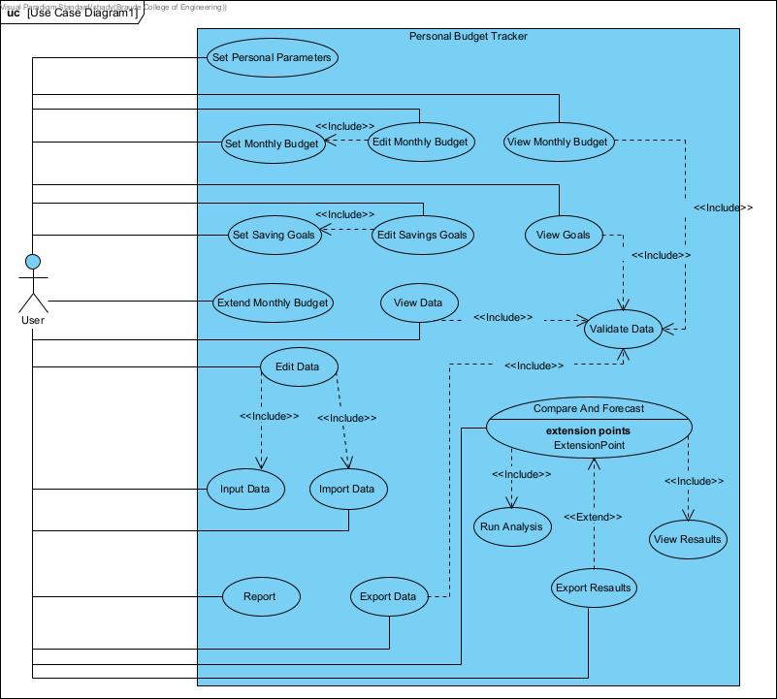

## 6.3 Activity diagram

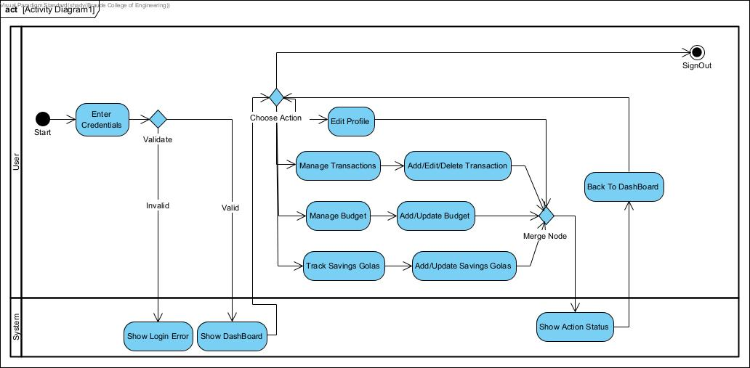

## 6.4 System Architecture

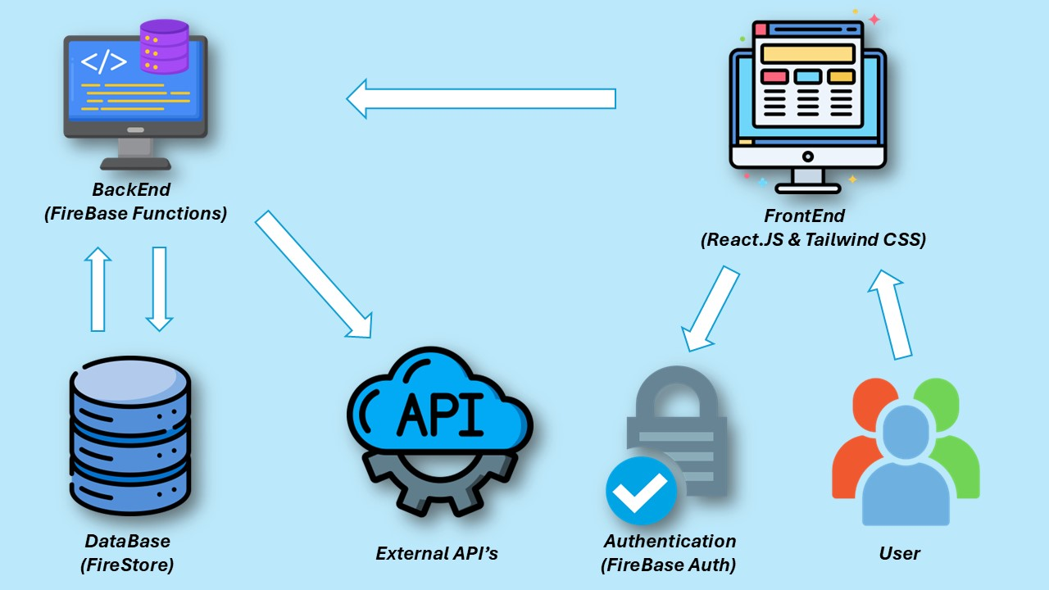

## 6.5. Graphical User Interface

### 6.5.1 Login / Register Interface

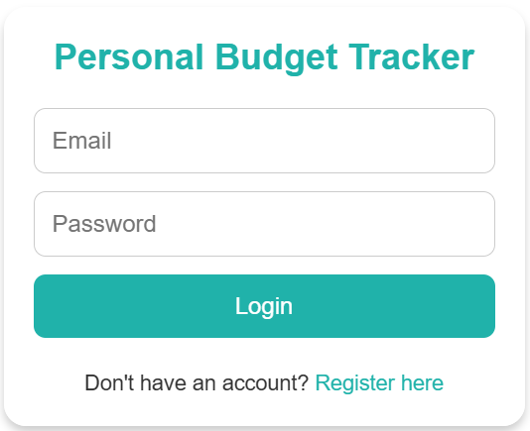

### 6.5.2 Home Page Interface

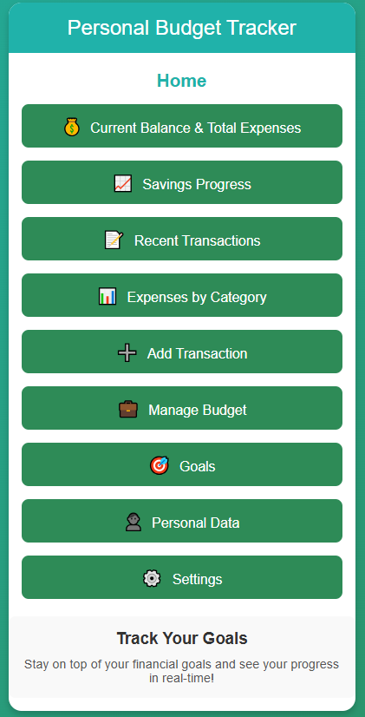

### 6.5.3 Budget Management Interface

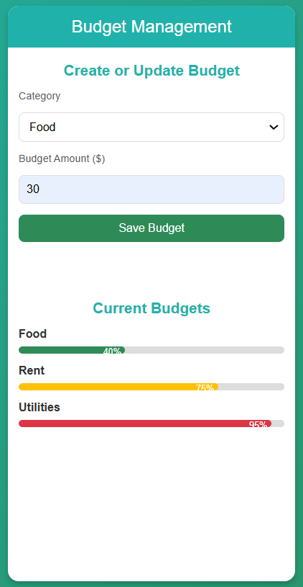

### 6.5.4 Savings Goals Interface

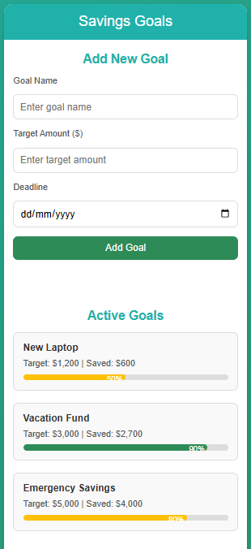

### 6.5.5 Transaction Management Interface

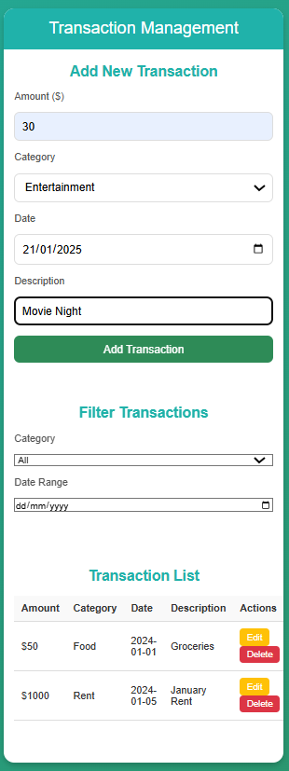

### 6.5.6 Data Visualization Interface

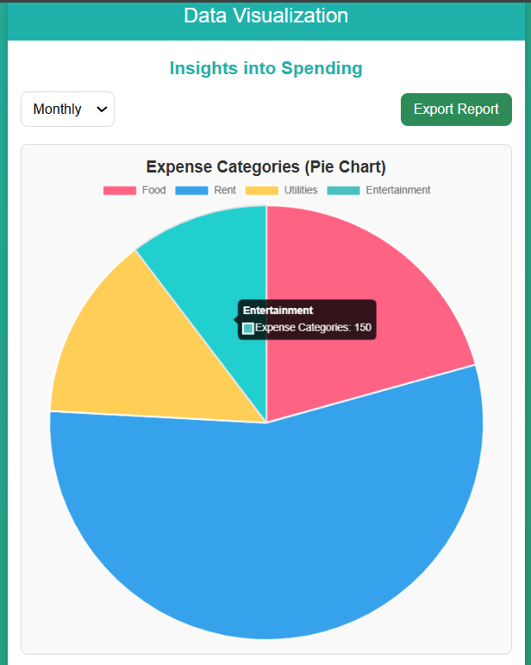

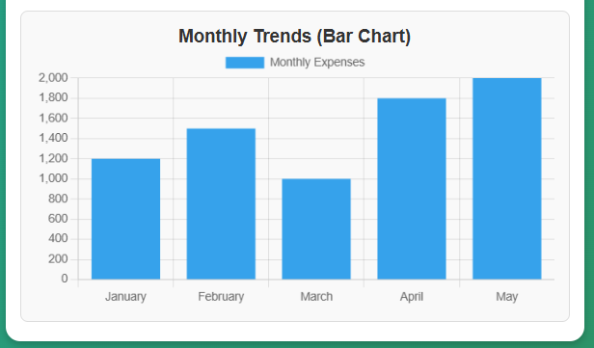

### 6.5.7 Profile Settings Interface

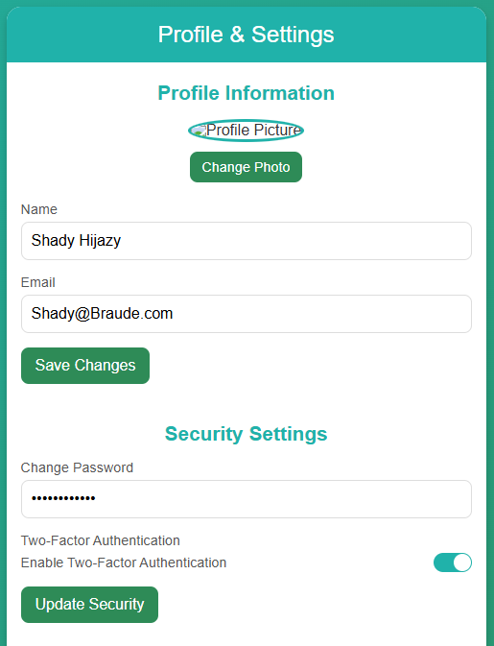

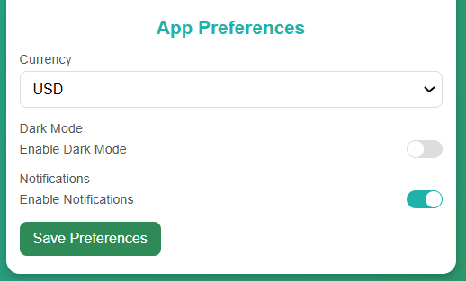

### 6.5.8 Help & Support Interface

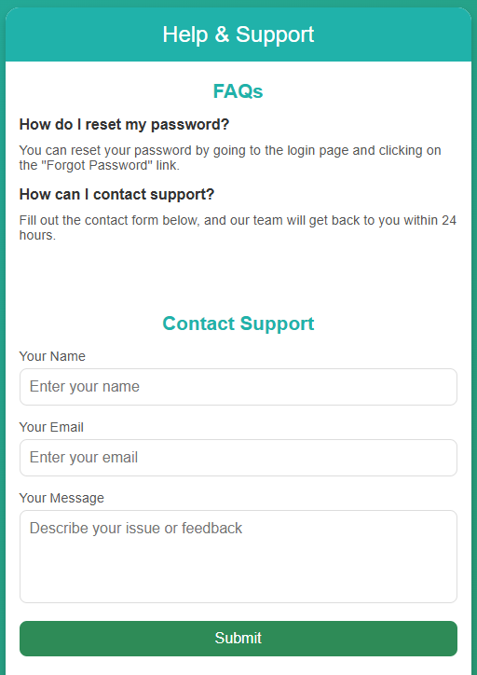



# References

Beebe, J. (2024, July 22). Pay Yourself First (PYF). Investopedia. <https://www.investopedia.com/terms/p/payyourselffirst.asp>

European Council. (2024, June 13). Data Protection Regulation. <https://www.consilium.europa.eu/en/policies/data-protection/data-protection-regulation/>

Kid's Money. (2024). Good budget Review: A Comprehensive Guide for College Students. <https://www.kidsmoney.org/college/budgeting/goodbudget-review/>

NerdWallet. (2024). YNAB App Review. <https://www.nerdwallet.com/article/finance/ynab-app-review>

Okiki, E. (2023). Apple Numbers vs. Google Sheets: A Comprehensive Comparison. CRM. <https://crm.org/news/apple-numbers-vs-google-sheets>

State of California Department of Justice. (2018, June 28). California Consumer Privacy Act (CCPA). <https://oag.ca.gov/privacy/ccpa>

UNFCU. (2024). Understanding the 50/30/20 Budgeting Rule. <https://www.unfcu.org/financial-wellness/50-30-20-rule/>

Web Content Accessibility Guidelines. (2020). WCAG 2.1. <https://www.w3.org/TR/WCAG21/>

Bank of America. (n.d.). Mobile and Online Banking Features. <https://www.bankofamerica.com/online-banking/mobile-and-online-banking-features/>

Chase Mobile App Reviews. (2024, November 26). Google Play Store. <https://play.google.com/store/apps/details/Chase_Mobile>

Discover. (2024). Values-Based Budgeting Guide. <https://www.discover.com/online-banking/banking-topics/values-based-budgeting/>

Experian. (2024). Best Mobile Banking Apps. <https://www.experian.com/blogs/ask-experian/best-mobile-banking-apps/>

Forbes. (2024). Reviews of Popular Budgeting Apps:

* Mint Budgeting App Review. <https://www.forbes.com/advisor/banking/mint-budgeting-app-review/>
* EveryDollar App Review. <https://www.forbes.com/advisor/banking/everydollar-app-review/>
* PocketGuard Budgeting App Review. <https://www.forbes.com/advisor/banking/pocketguard-budgeting-app-review/>

**Software Comparisons and Reviews**

LinuxLinks. (n.d.). Ledger: Command-Line Double-Entry Accounting System. <https://www.linuxlinks.com/ledger-powerful-command-line-double-entry-accounting-system/>

MobiSystems. (n.d.). What is Apple's Equivalent to Excel? <https://mobisystems.com/en-us/blog/industry-insights/what-is-apple-s-equivalent-to-excel>

SLANT. (2024). Software Comparison: GnuCash vs. KMyMoney. <https://www.slant.co/versus/8147/8150/~gnucash_vs_kmymoney>

SpreadSheetPoint. (2024). Excel vs. Numbers Comparison. <https://spreadsheetpoint.com/excel-vs-numbers/>

**Subscription Management**

JustUseApp. (2024, October). Bobby Track Subscriptions Reviews. <https://justuseapp.com/en/app/1059152023/bobby-track-subscriptions/reviews>

Subby. (2024). Subscription Manager for Android. <https://subby-the-subscription-manager.en.softonic.com/android>

**Budgeting Techniques**

Investopedia. (2024). Activity-Based Budgeting (ABB). <https://www.investopedia.com/terms/a/abb.asp>

Oracle. (n.d.). Zero-Based Budgeting Guide. <https://www.oracle.com/il-en/performance-management/planning/zero-based-budgeting/>

ThinkAhead. (2024). Comparing Budgeting Techniques. <https://www.accaglobal.com/gb/en/student/exam-support-resources/fundamentals-exams-study-resources/f5/technical-articles/comparing-budgeting-techniques.html>

Wikipedia. (2024, July 31). Envelope System. <https://en.wikipedia.org/wiki/Envelope_system>

**Articles we relied on :**

Chen, C., Bozorgzadeh, E., Srivastava, A., & Sarrafzadeh, M. (2002). Budget management with applications. *Algorithmica, 34*(3), 261–275. <https://doi.org/10.1007/s00453-002-0964-7>

**Balseiro, S., Kim, A., Mahdian, M., & Mirrokni, V. (2020).** Budget Management Strategies in Repeated Auctions. *SSRN Electronic Journal.* <https://ssrn.com/abstract=2858261>

**Kantsur, I. H., Hats, L. Ye., Kharchenko, T. B., Smahlo, O. V., & Prokopets, L. V. (2020).** Application of the Program-Target Method in Budget Management. *International Journal of Management, 11*(5), 1027-1035. <https://ssrn.com/abstract=3632650>

**Ljungman, G. (2009).** Top-down budgeting—An instrument to strengthen budget management. *IMF Working Paper, 09*(243). International Monetary Fund. <https://doi.org/10.5089/9781451874085.001>